**PROJECT REPORT**

**TO SUPPLY LEFTOVER FOOD TO POOR**

SUBMITTED BY:

|  |  |
| --- | --- |
| **SANDHIYA A** | **710621104041** |
| **RISHWANTH S** | **710621104036** |
| **SIRAN KUMAR C** | **710621104311** |
| **ASHWIN N** | **710621104004** |

**BECHELOR OF ENGINEERING**

**IN SEVENTH SEMESTER**

**COMPUTER SCIENCE AND ENGINEERING**

**CSI COLLEGE OF ENGINEERING , KETTI ANNA UNIVERSITY : CHENNAI 600025**

**NOVEMBER – 2024**

**TO SUPPLY LEFTOVER FOOD TO POOR**

# Project overview :

The primary objective of this project is to create a platform leveraging Salesforce technology to efficiently connect surplus food from various sources with organizations or individuals in need. This initiative aims to minimize food wastage and alleviate hunger by facilitating the redistribution of excess food to those who are food insecure.

**Objectives:**

## Business Goals:

**Reduce Food Waste:**

Minimize the amount of edible food discarded by food donors.

## Increase Food Accessibility:

Provide surplus food to vulnerable communities, addressing food insecurity and hunger.

## Build Strategic Partnerships:

Foster collaborations with food donors, recipients, and other stakeholders to amplify the project's impact.

## Ensure Operational Efficiency:

Streamline food recovery, storage, and distribution processes to maximize resources.

## Promote Community Engagement:

Raise awareness about food waste and hunger, encouraging community involvement and support.

# Specific Outcomes:

## Food Recovery:

Recover at least 500 meals per week from food donors. Increase food recovery by 20% quarterly.

## Food Distribution:

Deliver food to at least 10 different recipient organizations per month. Ensure timely delivery of food to recipients within 24 hours of pickup.

## Recipient Satisfaction:

Achieve a recipient satisfaction rate of 90% or higher.

Provide nutritional information and meal planning resources to recipients.

## Partnership Development:

Establish partnerships with at least 5 new food donors per quarter. Collaborate with local organizations to increase food access and awareness.

## Operational Efficiency:

Develop an efficient food pickup and delivery schedule.

Implement a system for tracking food inventory and expiration dates.

## Community Engagement:

Host at least 2 community events per quarter to raise awareness about food waste and hunger.

# Salesforce Key Features and Concepts Utilized

## Custom Objects:

Custom objects allow you to store specialized information that doesn’t fit within the standard data models of a software platform. Here’s how each of the custom objects works within the context of food donation and distribution:

## Food Donations:

Purpose: Track details about food donations, including the type of food, quantity, and expiration date.

Details Stored: Type of food (e.g., canned goods, fresh produce, packaged meals), quantity (e.g., weight or volume), expiration dates (important for ensuring food safety), donor information, and any specific conditions or requirements for the donation (e.g., perishable, dietary considerations).

## Recipients:

Purpose: Store information about those receiving the food donations, including personal details and preferences.

Details Stored: Name, contact information, location (address for delivery), dietary restrictions (e.g., vegetarian, gluten-free, allergies), and eligibility (e.g., income level, family size, community needs).

## Logistics:

Purpose: Track transportation, delivery schedules, and logistics management to ensure food reaches the recipients efficiently.

Details Stored: Transportation details (e.g., vehicles, drivers), delivery routes, schedules, and coordination with external partners or logistics providers.

## Distribution:

Purpose: Store information related to the actual distribution of food to recipients.

Details Stored: Delivery locations, distribution centers, recipient feedback (e.g., satisfaction, special requests), and tracking of how much food was delivered to whom.

## Workflows:

Workflows automate key processes to streamline operations and ensure consistency.

## Food Donation Registration and Tracking:

Automated system for recording donated items, assigning them to the correct categories, checking for expiration dates, and tracking their movement through the system.

## Recipient Registration and Matching:

Workflow that automates recipient sign-up, eligibility verification, and matching them with available food donations based on their dietary needs and delivery preferences.

## Logistics Coordination and Scheduling:

Workflow automating the assignment of logistics tasks such as scheduling transportation, assigning routes to drivers, and ensuring timely food delivery.

## Distribution and Delivery Tracking:

Workflow that tracks food distribution status, confirms deliveries, and captures recipient feedback on food quality and timeliness of delivery.

## Approval Processes:

Approval processes help ensure that donations, recipients, and logistics meet certain criteria before proceeding.

## Food Donation Approval:

Ensures that donations meet safety and quality standards (e.g.checking expiration dates, ensuring food is properly packaged).

## Recipient Approval:

Verifies that recipients are eligible for assistance based on their needs, such as income level, dietary restrictions, and community guidelines.

## Logistics Approval:

Confirms that logistical resources (e.g., vehicles, drivers) are available and that transportation schedules align with delivery needs.

## Distribution Approval:

Ensures that food is distributed to the correct recipients and that delivery capacity is sufficient to meet demand, based on feedback and program constraints.

## Reports and Dashboards:

These are essential tools for tracking performance and making data-driven decisions:

## Food Recovery Rates:

Measure how much donated food is successfully collected and distributed versus food that is wasted or unclaimed.

## Recipient Satisfaction:

Track feedback from recipients to evaluate the quality of the service and food, and identify areas for improvement.

## Program Growth:

Monitor the expansion of the program (e.g., number of recipients served, number of new food donors).

## Logistics Efficiency:

Track transportation metrics, including delivery time, cost, and vehicle utilization.

## Distribution Effectiveness:

Assess how well food is reaching recipients, including measuring food delivery accuracy and timeliness.

## Mobile App:

A mobile app helps streamline the interaction for both food donors and recipients, making it easier for them to engage with the program. Key features could include:

Food Donation Registration: Donors can easily register their food donations, track their contributions, and view the status of donations.

Request and Track Food Deliveries: Recipients can request food deliveries, track their status, and communicate with delivery teams.

Access to Information: Recipients and donors can access important program information, such as eligibility criteria, donation guidelines, or program updates.

Feedback and Ratings: Recipients can rate the quality of food received, the timeliness of delivery, and the overall service, providing valuable feedback for improvements.

## Marketing Automation:

Marketing automation helps maintain communication with recipients and donors, enhancing engagement and program participation:

## Email and SMS Notifications:

Automated messages to inform recipients about upcoming deliveries, food availability, or program updates.

## Personalized Messaging and Content:

Tailored communication based on recipient profiles, dietary needs, or donation history to create more relevant engagement.

## Recipient Segmentation and Targeting:

Segmentation based on factors like dietary restrictions, location, or historical donations to send more personalized and relevant messages.

## Campaign Tracking and Analysis:

Tools to measure the effectiveness of communication campaigns, helping improve engagement and ensure the program is reaching the right people.

## Data Analytics:

Data analytics features provide insights into how the program is performing and help drive continuous improvement:

## Data Visualization and Reporting:

Dashboards and visual reports help stakeholders quickly understand the performance of the program and identify trends**.**

## Predictive Analytics and Modeling:

Use historical data to forecast food needs, identify patterns in donations, or predict logistical challenges.

## Program Evaluation and Impact Assessment:

Assess how well the program is meeting its goals, including recipient satisfaction, food waste reduction, and community impact.

## Operational Efficiency and Effectiveness Analysis:

Measure and optimize resource utilization (e.g., transportation, staff), ensuring maximum impact with minimum waste.

# Detailed Steps to Solution Design

## Define Project Requirements

Identify the problem statement: Supply leftover food to the poor Determine the project goals and objectives

Gather requirements from stakeholders

## Analyze Requirements

Analyze the requirements gathered in project requirements Identify the functional and non-functional requirements Create a requirements specification document

## Design Solution Architecture

Determine the overall solution architecture Identify the components and modules required Create a high-level design document

## Design Data Model

Determine the data entities and relationships Create a data model diagram

Identify the data sources and integrations required

## Design User Interface

Determine the user interface requirements Create wireframes and mockups

Identify the user experience and user journey **Design Workflows and Approvals** Determine the workflows and approvals required Create a workflow diagram

Identify the roles and responsibilities

## Design Reports and Dashboards

Determine the reporting and dashboard requirements Create a report and dashboard design document Identify the key performance indicators (KPIs) **Design Mobile App**

Determine the mobile app requirements

Create a mobile app design document

Identify the mobile app features and functionalities **Step 9: Design Marketing Automation** Determine the marketing automation requirements Create a marketing automation design document

Identify the marketing automation workflows and approvals

## Design Data Analytics

Determine the data analytics requirements Create a data analytics design document

Identify the data analytics workflows and approvals

## Develop Solution

Develop the solution based on the design documents Conduct unit testing and integration testing

Deploy the solution to production

**Test and Quality Assurance** Conduct thorough testing of the solution Identify and fix defects

Conduct performance and security testing

## Deploy and Implement

Deploy the solution to production

Implement the solution in the live environment

Conduct post-implementation review and gather feedback.

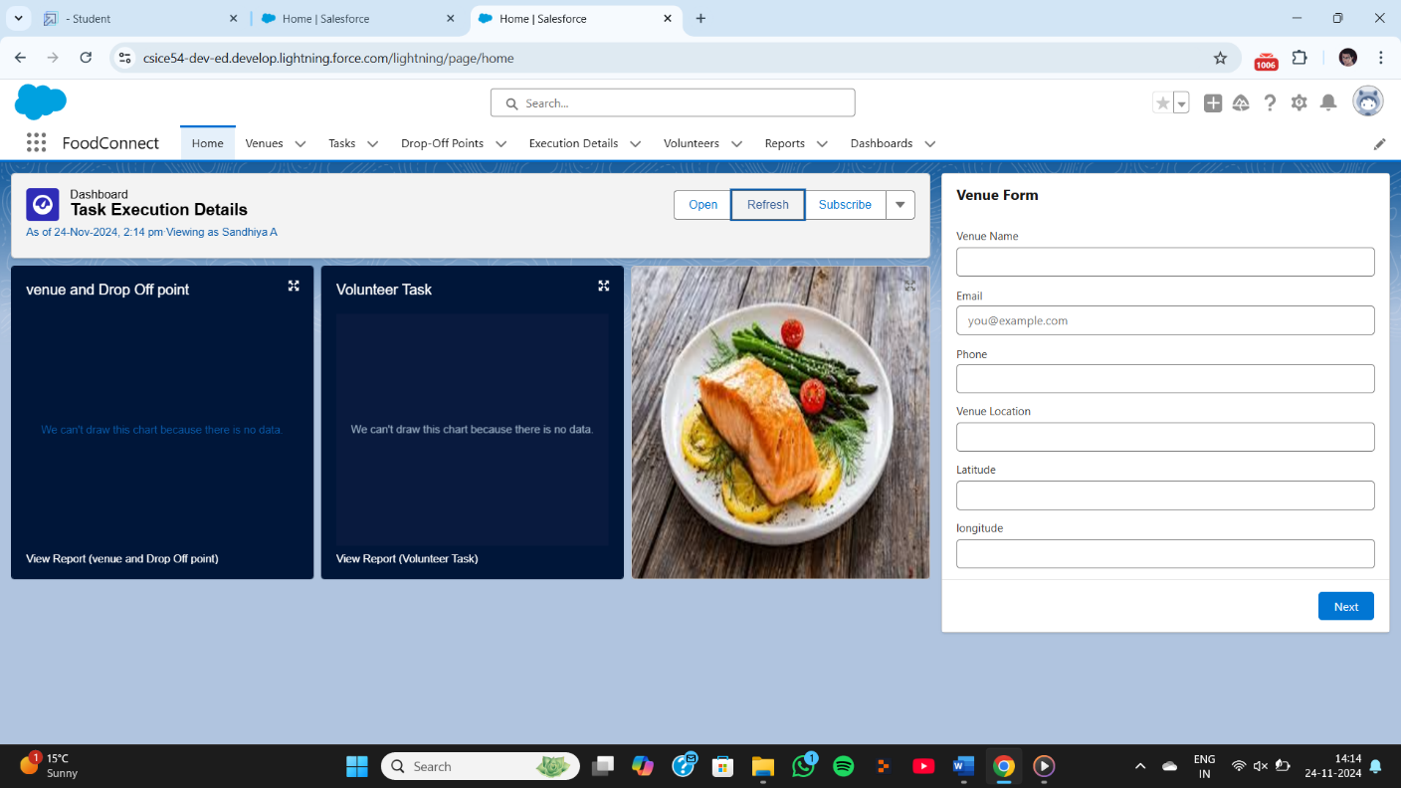

# Testing and Validation

## Unit Testing (Apex Classes, Triggers)

Unit testing is a crucial aspect of Salesforce development, ensuring that individual code units work correctly and produce the expected results. This involves testing Apex classes and triggers, which are used to write custom business logic in Salesforce. By conducting unit tests, developers can detect bugs and errors early in the development cycle, reducing debugging time and effort. Unit testing also improves code quality and reliability, ensuring that the application functions as intended. Tools like Apex Test, TestNG, and Mockito are commonly used for unit testing in Salesforce.

## User Interface Testing

User interface testing is essential to ensure that the Salesforce application provides a seamless and intuitive user experience. This involves testing the visual elements, layout, and user interactions of the application, such as clicking, hovering, and scrolling. By conducting user interface testing, developers can detect UI-related bugs and errors, improving user satisfaction and adoption. This type of testing also enhances the overall user experience, making it easier for users to navigate and use the application. Tools like Selenium, Cypress, and TestComplete are commonly used for user interface testing in Salesforce.

# Key Scenarios Addressed by Salesforce in the Implementation

## Food donation management:

Salesforce can handle food donation registration, tracking, and management, ensuring that surplus food is efficiently collected and redistributed to those in need.

## Recipient management:

Salesforce can manage recipient information, preferences, and eligibility, ensuring that food is delivered to the intended beneficiaries.

## Logistics coordination:

Salesforce can optimize logistics for food pickup and delivery, reducing food waste and ensuring timely delivery to those in need.

## Food distribution tracking:

Salesforce can track food distribution in real-time, enabling organizations to monitor and manage food delivery to the poor.

## Reporting and analytics:

Salesforce can provide real-time reporting and analytics, enabling organizations to measure the impact of their food recovery efforts and identify areas for improvement.

## Partner management:

Salesforce can manage partnerships with food donors, volunteers, and other stakeholders, ensuring effective collaboration and resource allocation.

# Conclusion

This food donation and distribution project, designed to supply leftover food to the poor, presents a comprehensive, data-driven solution to address food insecurity while minimizing food waste. By implementing a well-structured system for food recovery, recipient matching, logistics coordination, and distribution, the program can effectively support vulnerable communities, ensuring that surplus food reaches those in need in a timely and organized manner.